Charlie Tubbritt (20080486) & Elizabeth Solomon (20103319)

  Communications Assignment

Workshop

Contents

Overview 2

Goals 3

Objectives 3

Audience 3

Pre-planning Activities 4

Design/Sequence of Events 7

Feedback 8

Conclusion/Reflection 8

# Overview

We chose to do an event, our audience will be venture scouts and it will be hosted within their local scout hall. Our goal is to address competitiveness within scouting and its effect on mental health. Our event will involve sequential activities that relieve stress and will educate them on mental health and how to manage in high stress environments.

We believe the best way to educate on mental health is to allow those with first hand experience to speak on the topic. This is why for our first activity we have invited Rover Scouts, the people an age group above our Ventures, to speak to the group directly. After the Rovers, a key speaker will also be offered the opportunity to talk about their experiences.

Following that we have organised a 30-minute led mindfulness session to give the Ventures an opportunity to think about the topics discussed and learn how to relax with that in mind. After that they are allowed to take a short break.

We are also of the mind that the younger generations relationship with food is often a significant issue. In the activity following their break we will have the ventures participate in a cooking exercise. We will show them a variety of different recipes that promote a balanced diet but still taste good. We have chosen one of these recipes to cook alongside the ventures.

Given that we will have tackled a number of serious problems throughout the course of the day we have decided for a final activity to allow the Ventures to unwind. We felt the best way to do this was to simply allow them to watch a movie while they eat the food they prepared.

Once we have completed all activities, Ventures will be encouraged to fill out a google form that will be made accessible to them and to participate in a “Highs and Lows” discussion about the event. This is to gather feedback on the event so we will be able to discuss amongst ourselves if the event was a success and how we can fine tune it in future

# Goals

1. To address competitiveness within scouting and the adverse effects it has on the mental health of youth members.
2. Educate our audience on mental health topics and how to better manage their mental health within a competitive environment.
3. Offer a period for our audience to relax without having to consider the weight of topics discussed.

# Objectives

* 1. Many rovers have been Ventures in the past, this makes them qualified to speak on the pressures that can occur within Scouting.
  2. Rovers are also close to the age range of Ventures we feel this will allow the Venture to be more at ease when discussing their wellbeing.
  3. We will bring forward a key speaker to discuss their experiences with mental health and coping methods they developed.
  4. We are using the cooking activity to discuss ways to develop healthy eating habits and provide options for meals that are well balanced.
  5. The act of cooking will be a good opportunity to work hands on with the topic without needing to consider the weight of topics discussed.
  6. The Ventures will end the evening by watching a movie to unwind after the main topics of the event have been completed.

# Audience

When deliberating on what to plan for our event we eventually decided on the topic of mental health. This brought us to evaluate who would benefit most from an event or workshop based around mental health. Naturally we decided a group of teenagers would benefit most, particularly from ages 15-18.

Venture scouts who are aged 15-17 fit almost perfectly within this range. They are at an age where they are under additional pressure within school with their Leaving Certificate on the horizon. Scouting itself attracts people from a variety of background but can also foster a culture of competition. This considered, Ventures are especially vulnerable to poor mental health. After taking all of this into account we believe that this group was in particular need of event that tackles Mental Health and how to manage it.

Teenagers can be difficult to communicate with especially when it comes to something as serious as their mental wellbeing. We decided the best was to address this barrier was to bring forward Rover Scouts for the first event of the day. Rovers are group not much older than Ventures who have navigated issues they may currently be experiencing we felt they could resonate with each other. We also concluded that the topic at hand would bring our audience outside of their comfort zone. In response to this we felt it would be best to host them in a location familiar to them. This is why we are using a local scout hall as our venue. This is a controlled environment that they will be comfortable and familiar with.

# Pre-planning Activities

* Contact a local scout group to request permission for use of their hall.
* Make sign up form for Rovers willing to volunteer
  + <https://forms.gle/Knj1qyBaR6ARCQid9>
* Make a Facebook post for Rovers include sign up form.
* Organise Rovers attendance to speak at the event.
* Design flyer and email it to local venture groups to garner interest.
* Arrive at scout hall early to organise use of their equipment. Tables, gas stoves etc.
* Set up projector for use by rovers, key speaker, and ourselves for the movie.

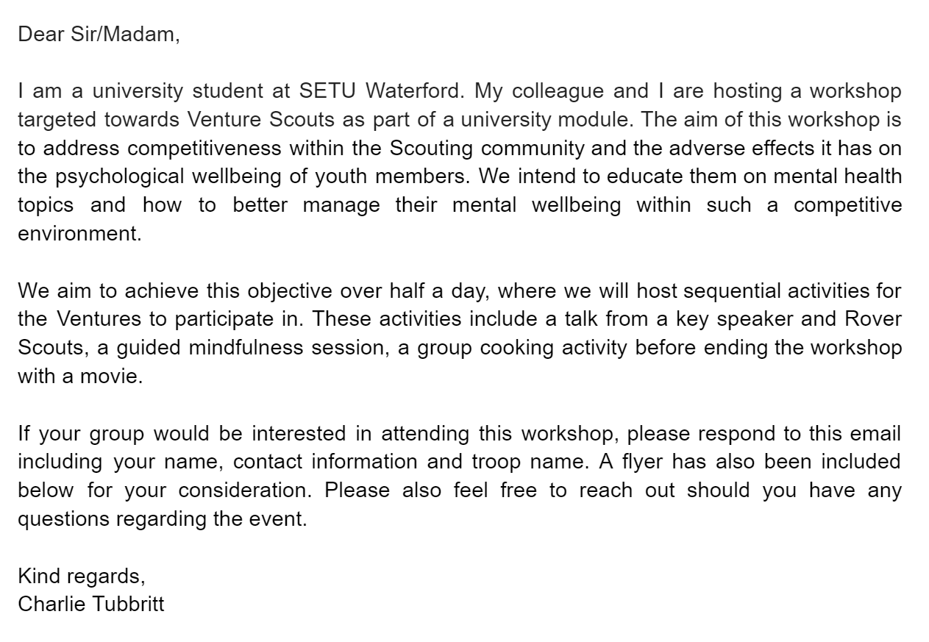

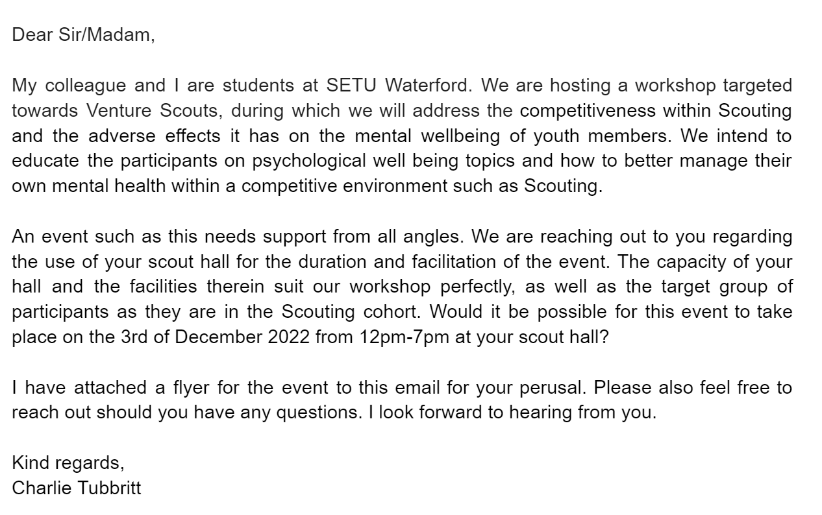

# Design/Sequence of Events

|  |  |  |
| --- | --- | --- |
| Time | Activities | Materials |
| 12-12.15pm | * Intro, who we are and why we are there. * To introduce the workshop, give an overview of the day & any other housekeeping details. | Name tags |
| 12.15-1.00 | * 15-minute talk from Rovers (older scouting group 18+) on mental health surrounding competitiveness * Key speaker. | Projector |
| 1.00-1.30 | * 30-minute host led mindfulness session | Roll/Yoga mat (Bring their own) |
| 1.30-2.00 | * Packed lunch break |  |
| 3.00 - 4.30 | * Discussion on balanced recipes * Cooking | * Tables * Ingredients * Gas Cookers * Recipe handouts |
| 4.30 - 6.30 | * Movie/Eat | * Movie (on USB) * Eating utensils * Delph |
| 6.30 - 7.00 | * Google Forms (scan code on screen after the movie) on how the teens liked the workshop and what they would change or add. * Highs/lows activities (groups activity where you form a circle each person offers up one high and one low | * QR for survey monkey * Mini goodie bag?   + Including summary pamphlet   + Sweets |
| 7:00 | * Clean up and packing * Leader round up and discussion | * Cleaning materials and storage |

# Feedback

We will have the ventures scan a QR code linking to a google form that will collect their answers and return them to us. We will also be including a common scout activity called “highs and lows” where the group sits in a circle and gives you, first, an aspect of the day they disliked and then an aspect of the day they didn’t like. We will also consider this as feedback. All feedback provided from the Ventures will be used to improve this workshop further.

# Conclusion/Reflection

Curating this event led us to consider the influence of mental health on youth members in scouting, which we gained significant insight on. We felt this was an enlightening experience. Once we had finished the project, we considered the impact it would have on this age group. After careful evaluation we felt it would be hugely beneficial in practice and something that should be considered by Scouting Ireland in the future.

From an academic point of view there was a lot of benefit to this project. Structuring this project allowed us to work on our attention to detail, notably around choosing our audience. There was a lot to evaluate when choosing Ventures as our audience. We had to ask ourselves, “Would this group benefit most from the idea we have in place?”. Both of us were lacking in terms of collaborative skills when we started this project but at its completion, we feel those skill have improved noticeably. Lastly, in terms of soft skills, we feel our organisational skills developed most. Every aspect of this project demanded we implement what organisational skills we had, and we feel the development shows throughout our project.